**Topic 4: Sampling Distributions Solutions**

**Q1**

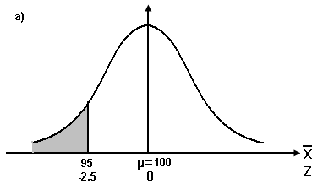Since the population is normal [], the sampling distribution of the mean is also normal []

a) 



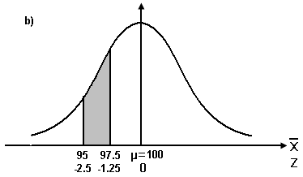

b) 



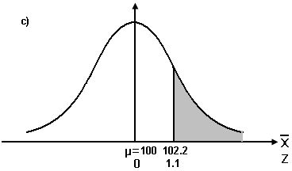

c) 



d) Let Xo be the value that 65 % chance that  is above

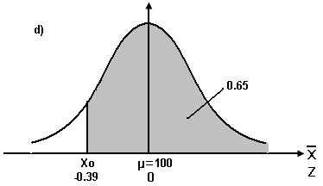



Since 



$x_{0}=99.22$

**Q2**

1. Since the population is normal [], the sampling distribution of the mean is also normal []
2. 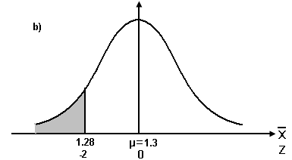Let  be the sample mean of the diameter of a brand of Ping-Pong balls



1. 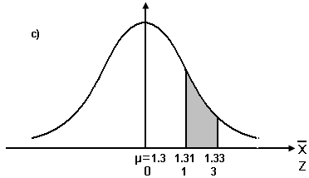



d) Let Xlower be the lower value and Xupper be the upper value





For symmetric distribution of probability (0.6) on both sides of ,

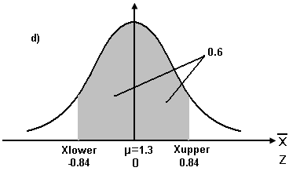Since  and ,









Hence, 60% of the sample means will be between 1.2916 inches and 1.3084 inches.

**Q3**

Since the population is normal [], the sampling distribution of the mean is also normal []

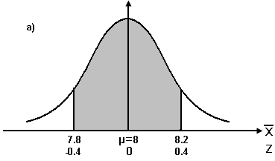a) Let be the sample mean of the time spent using e-mail per session

= 

= 

= 0.6554 – 0.3446

= 0.3108

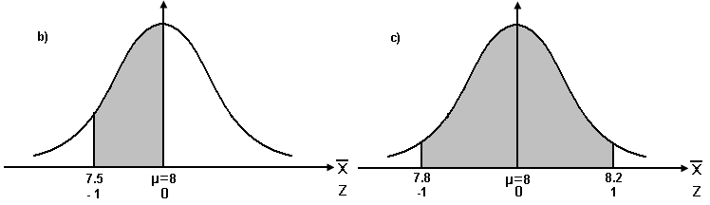b) = 

= 

= 0.5 – 0.1587

= 0.3413

1. 

 = 

= 

= 0.8413 – 0.1587

= 0.6826

d) With the sample size increasing from n = 16 to n = 100, more sample means will be closer to the population mean. The standard error of the sample mean of size 100 is much smaller than that of size 16, so the likelihood(probability) that the sample mean will fall within 0.2 minutes of the population mean is much higher for samples of size 100 (probability = 0.6826) than for samples of size 16 (probability = 0.3108).

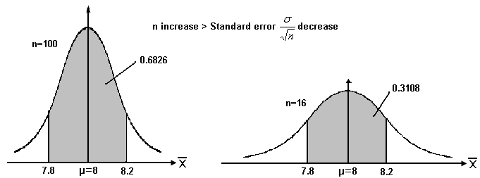

**Q4**

Let X be the weight of the student



By Central Limit Theorem, the Sampling Distribution of Mean is normal.



Pr (Total weight of 36 students) =Pr) =Pr 

=Pr () = 0.9429

**Q5**

Let  be the average loading time

Since the population is normally distribution, sampling distribution of mean is approximately normal, 

P(Total time of 5 computers ≥ 15 )

= P(≥) = P(≥3) = P(Z≥) = P( Z≥0) = 0.5

**Q6**

a) , 

b) Possible values and probability distribution of 

|  |  |
| --- | --- |
|  | P() |
| 18 | 1/9 |
| 19 | 2/9 |
| 20 | 3/9 |
| 21 | 2/9 |
| 22 | 1/9 |

c) , , so 

d)  , , so 

e) The sampling distribution of  does not follow a Normal Distribution.

Reasons: - population distribution of X is not normal

- n < 30, cannot apply Central Limit Theorem

**Q7**

1. Sample mean and sample standard deviation are reasonable estimators of population mean and population standard deviation.
2. According to Central Limit Theorem, with large sample size (n = 344), sample meanfollows a normal distribution approximately, with mean 19.1 and s.d. 
3. =1- 
4. =0
5. =0.5

 years

1. Yes. The population mean will be less than 19.1 years because for a normal distribution mean is equal to median. However, now we observe =0.2<0.5. Therefore, the population mean should be less than 19.1 years.